# **Department of Computer Science and Engineering Islamic University of Technology (IUT)** A subsidiary organ of OIC

# **Laboratory Report**

# CSE 4412: Data Communication and Networking Lab

## 

|  |  |
| --- | --- |
| **Name** | **: M M Nazmul Hossain** |
| **Student ID** | **: 200042118** |
| **Section** | **: 1** |
| **Semester** | **: 4th** |
| **Academic Year** | **: 2021-2022** |
| **Date of Submission** | **: 16.01.2023** |
| **Lab No** | **: 2** |

### **Title:** Understanding the basics of OSI Model

### **Objective**:

1. Examine HTTP Web Traffic
2. Display Elements of the TCP/IP Protocol Suite

### **Devices/ Software Used**: Cisco Packet Tracer: Web Server and Web Client

### **Working Procedure:**

There is no working procedure for this lab as the setup was provided to us. The procedures were demonstrated.

### **Diagram of the experiment:**

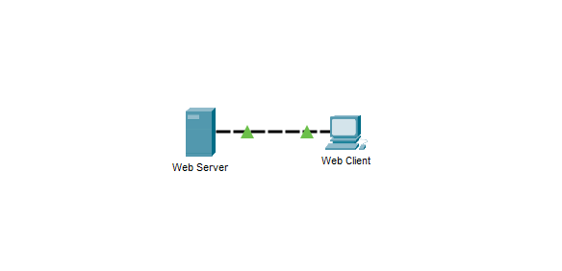

### **Observation**:

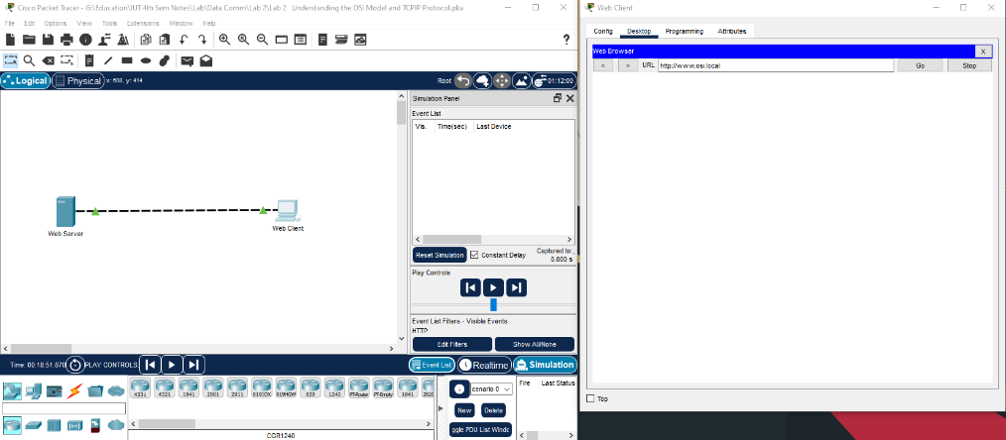**Event – 1**

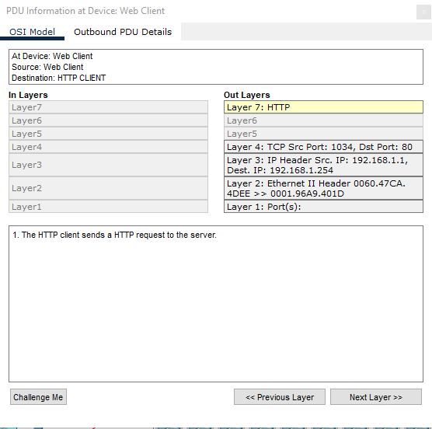

The Web Client sends out an HTTP request to the server. In the different layers, the data is stored as packets by TCP, and source and destination addresses are determined. The source port is found to be **1034** and the destination port is found to be **80**. The source IP address is found to be **192.168.1.1**. and the Destination IP address is **192.168.1.254**. The destination MAC address is also found to be **0060.47CA.4DEE** for the source and **0001.96A9.401D** for the destination. The device encapsulates the PDU into an Ethernet frame.

**Event – 2**

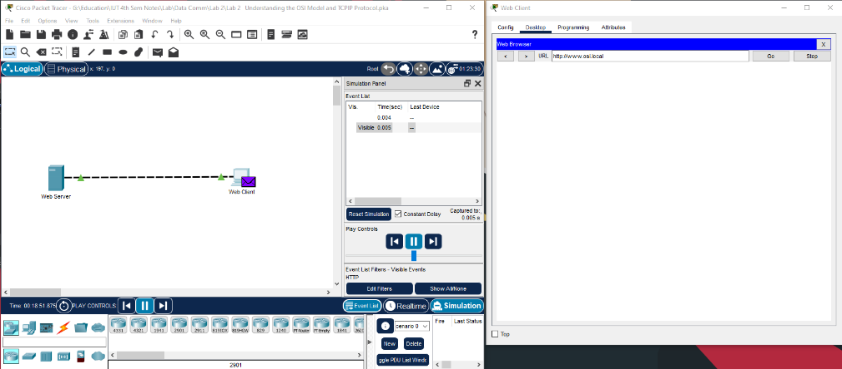

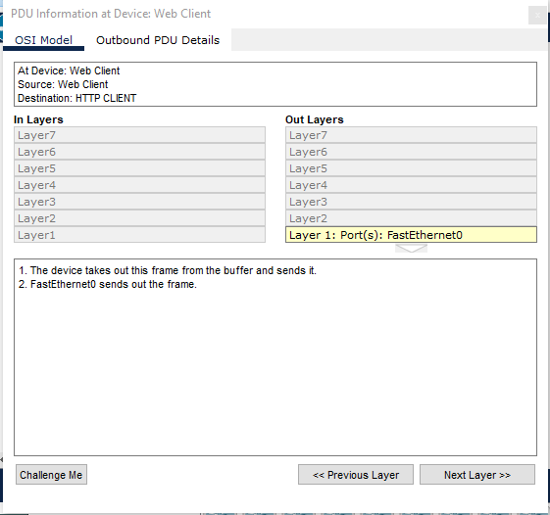

The device takes out the frame from the buffer and sends the request at the desired address, to the Web Server in this event. FastEthernet0 sends out the frame.

**Event – 3**

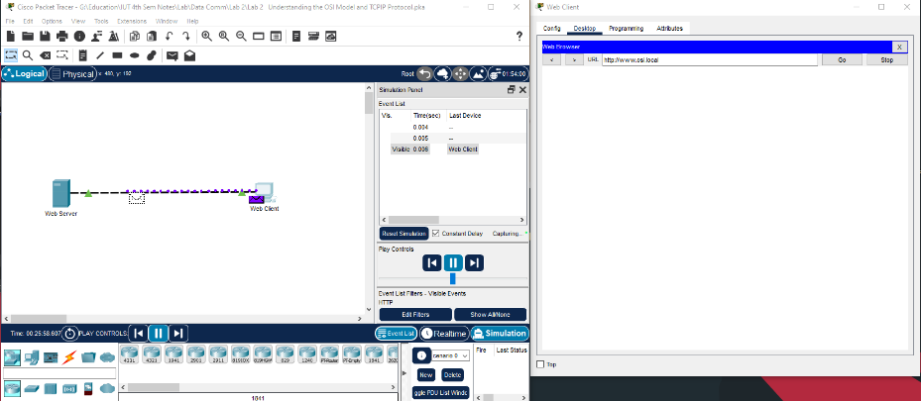

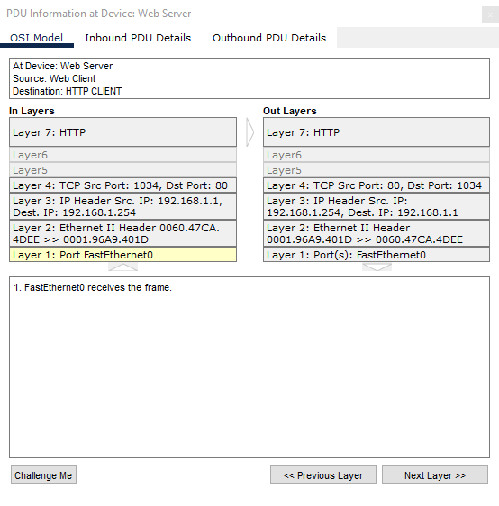

**In Layers**

The frame is received at the Web Server and decrypted to match the addresses. The Mac address, IP Address and Port addresses are matched. The source is found to be our Web Client and the Destination is found to be the Web Server. Finally, the Web Server receives the Web Clients request after TCP decrypts the sent data.

**Out Layers**

After receiving the request, the server sends back an HTTP reply to the client. The process is similar to event-1 except this time around the source and destination addresses are switched. The source port is found to be **80** and the destination port is found to be **1034**. The source IP address is found to be **192.168.1.254**. and the Destination IP address is **192.168.1.1**. The destination MAC address is also found to be **0001.96A9.401D** for the source and **0060.47CA.4DEE** for the destination. The device encapsulates the PDU into an Ethernet frame and FastEthernet0 sends out the frame.

**Event – 4**

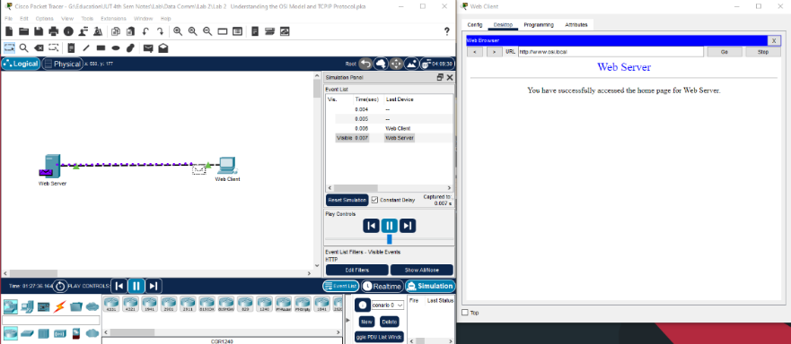

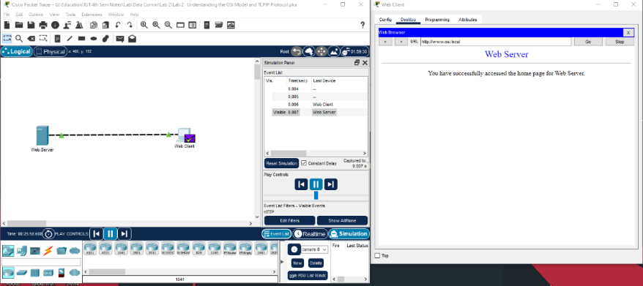

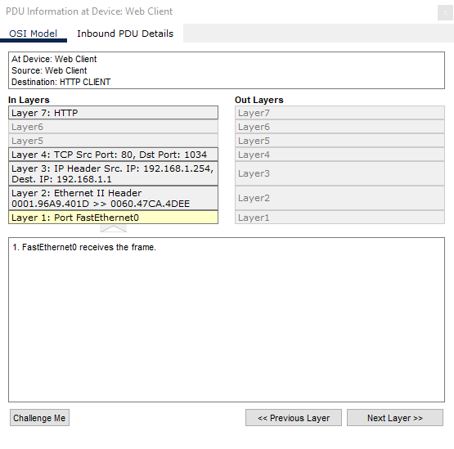

### The Web Client receives the frame. The frame is decrypted to get the addresses stored in it. The Mac address, IP address, and port address are all following the source and destination. The source is identified as our Web Server, and the destination is identified as the Web Client. Finally, the Web Client receives the HTTP response from the web Server and renders the page in the Web Browser.

### **Challenges:**

I encountered no difficulties in this lab because the procedure was a demonstration. All we had to do was jot down all the points raised during the discussion. It's difficult for me to understand why Event-2 is distinct from Event-1. As seen in Event-3, the HTTP request could be sent automatically in the same event. It is most likely due to the frame buffer. FastEthernet0 most likely had to check the buffer before sending the request.